# PTE 考试特点

全电脑阅卷

# One Month Plan

# Speaking

## 题型

1.1 Personal Introduction

1.2 Read Aloud

1.3 Repeat Sentence

1.4 Describe Image

1.5 Re-tell Lecture

1.6 Answer Short Question

## 口语评分规则：

* 内容
* 发音
* 流利度

### 内容

**Content 关键词有没有答对，依据题型不同**

### 发音

**Pronunciation & Oral Fluency**

**All vowels and consonants are easily understood 元辅音读清楚**

**Use appropriate assimilation and deletions for continuous speech 有节奏，语音同化需要省略**

**Stress is placed correctly in all words and sentence-level stress is fully appropriate 重读， 抑扬顿挫**

### 流利度

**Smooth rhythm and phrasing. No hesitations, repetitions, false-starts or non-native phonological simplifications 口语流利度非常重要，具体要做到：**

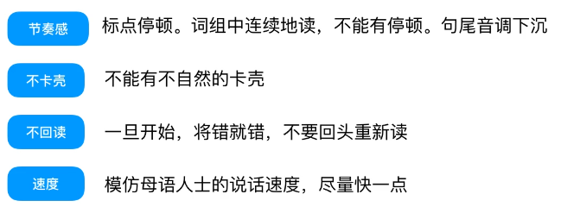

## 口语技巧总结（萤火虫）

* 口齿清楚，元音饱满
* 实词重读， 虚词弱读
* 意群最后一个诗词拖长音，放慢语速不停顿

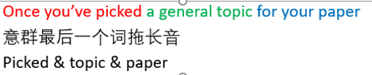

* 辅音结尾元音开头：连读

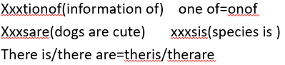

* 在s后有爆破辅音：浊化

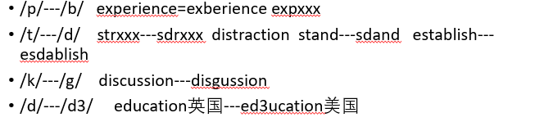

* 三种情况下 吞音

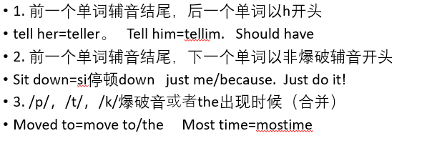

区分动词过去式发音

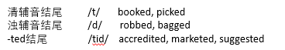

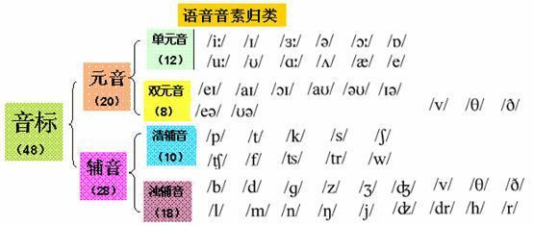

## Introduction

**25 seconds** to read prompt and prepare

**30 seconds** to record

**It’s not scored, but get prepared with it**

## Read Aloud (6-7, Reading & Speaking)

### Requirement

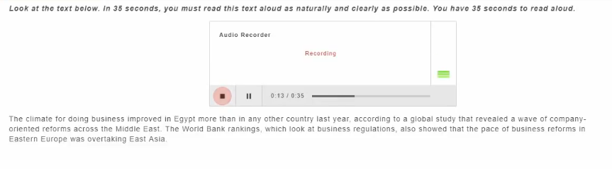

Read a text no more than 60 words, Speak after tone

**30-40s to prepare, Record length depends on the paragraph**

Scored on:

* Content: 内容是否一致
* Oral Fluency：是否连贯
* Pronunciation：发音是否标准

### Tips

Speak Clearly, Don’t Rush!

If remain silent for longer than 3 seconds, the recording will stop

Use 30-40 preparation time to decide （提前准备）:

* **Where to pause**
* **Which word to stress**

**语速要相对的快，在official sample中C1的语速明显快于B1和B2**

**保持口齿清晰，声音不要小**！

### 总结

1. **千万不要捏着嗓子念! 第一次念往往分高，之后就低了是因为捏着嗓子导致发音不清晰！**
2. **一些基本单词读的就有问题，比如Although，是要咬着舌尖发音的！**
3. **不只是句子的语调变化，单词的发音尤其是语调也一定要注意！我有很多词读音是对的但音调不对！不要总是上扬，大部分词末尾压下来， source↓ of rejuvenation↓**
4. **不能太慢，PTE跟读很慢但是慢必低分**
5. **And, to, into 这些虚词要弱读，我有重读这些词的习惯必须改正**
6. **读的时候不要太带感情, 多余的感情变化会影响读音**
7. **复杂单词可以稍微放慢来读清楚，不要快速带过，如Development， 快读的话会口齿不清导致扣分，这在RS中尤其重要！！<https://www.apeuni.com/zh-CN/practice/repeat_sentences/44>， 在这题中，修正了Development的读音之后分数就从68上升到了86**

### 进度

APEUNI 包含同步跟读的题：

#### # 329 https://www.apeuni.com/zh-CN/practice/shadowing/329

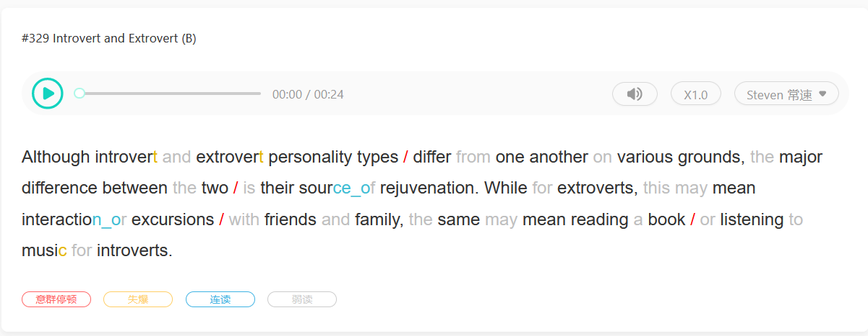

#### # 325 https://www.apeuni.com/zh-CN/practice/shadowing/329

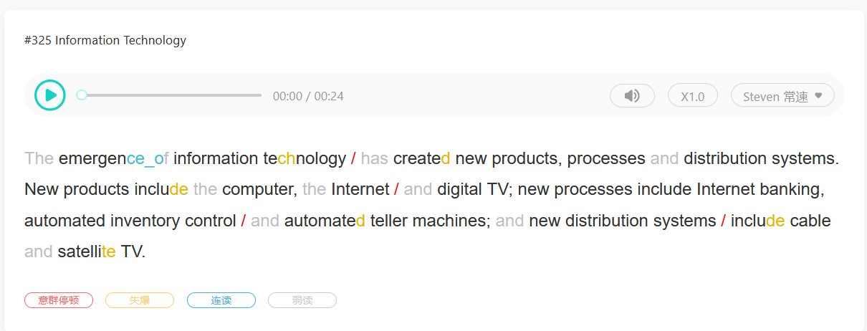

#### #324 https://www.apeuni.com/zh-CN/practice/shadowing/324

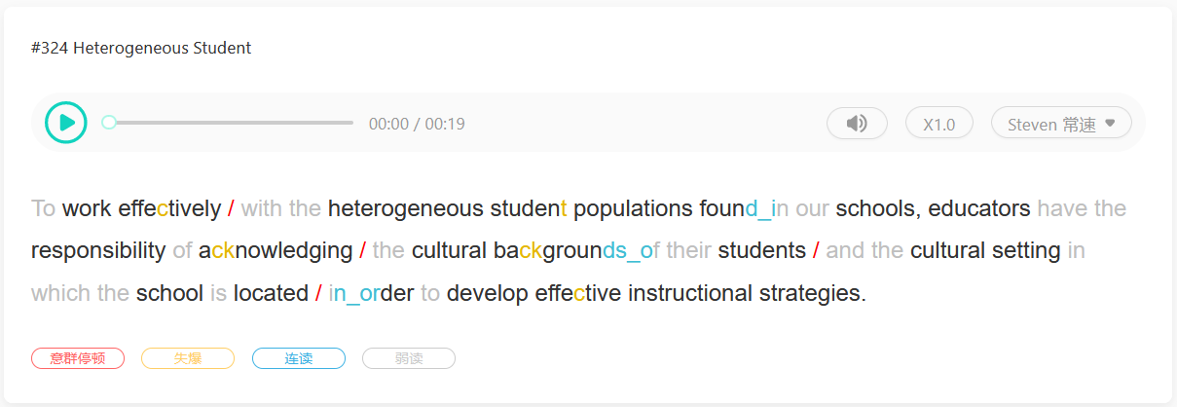

#### #117 <https://www.apeuni.com/zh-CN/practice/shadowing/117>

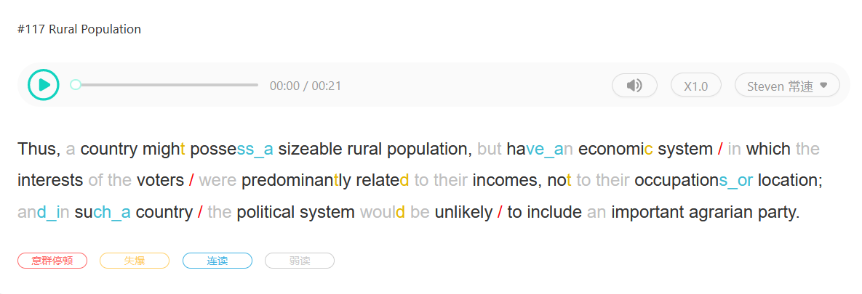

#### #322 https://www.apeuni.com/zh-CN/practice/shadowing/322

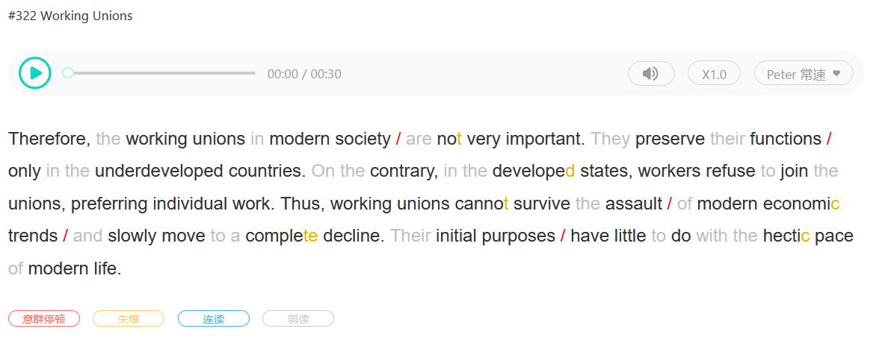

#### # 321 https://www.apeuni.com/zh-CN/practice/read_alouds/321

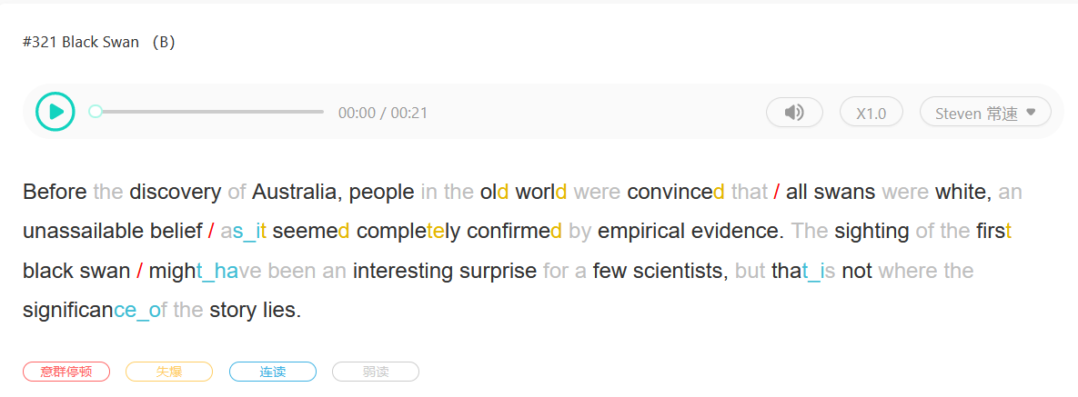

#### #320 https://www.apeuni.com/zh-CN/practice/shadowing/320

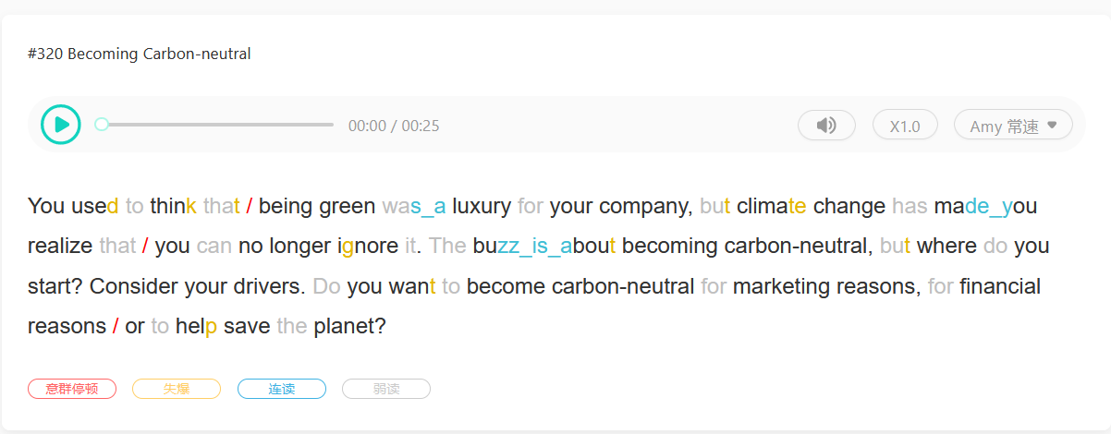

#### #94 https://www.apeuni.com/zh-CN/practice/shadowing/94

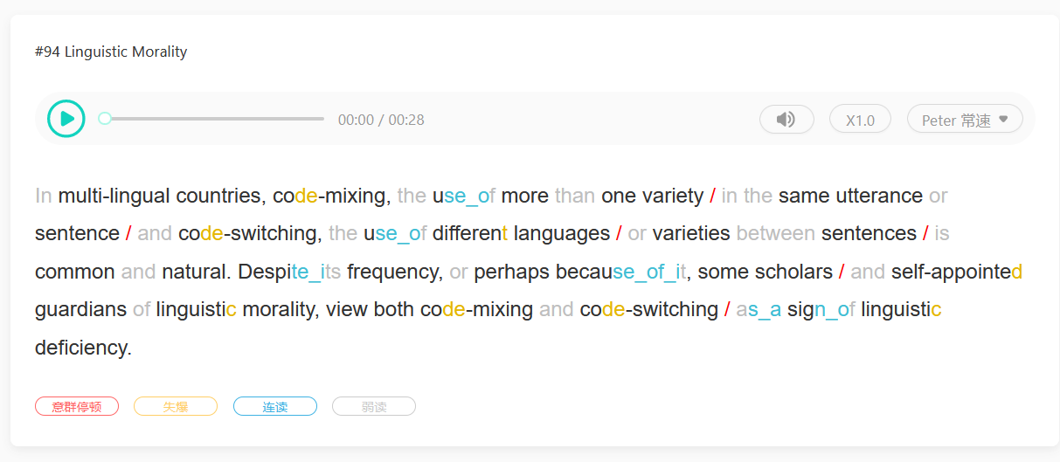

这道题得分很低甚至不能上70。读的时候是否少带一些感情比较好？(语调不要过于夸张)因为我有自己改变语调的坏习惯。

#### #319 <https://www.apeuni.com/zh-CN/practice/shadowing/319>

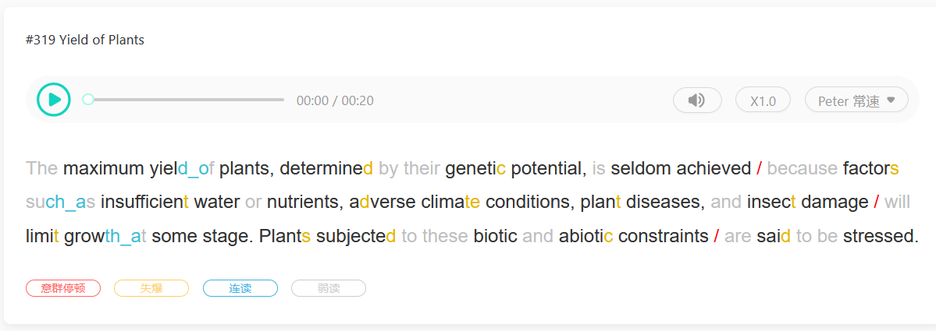

失爆到底该怎么做？

#### #317 <https://www.apeuni.com/zh-CN/practice/shadowing/317>

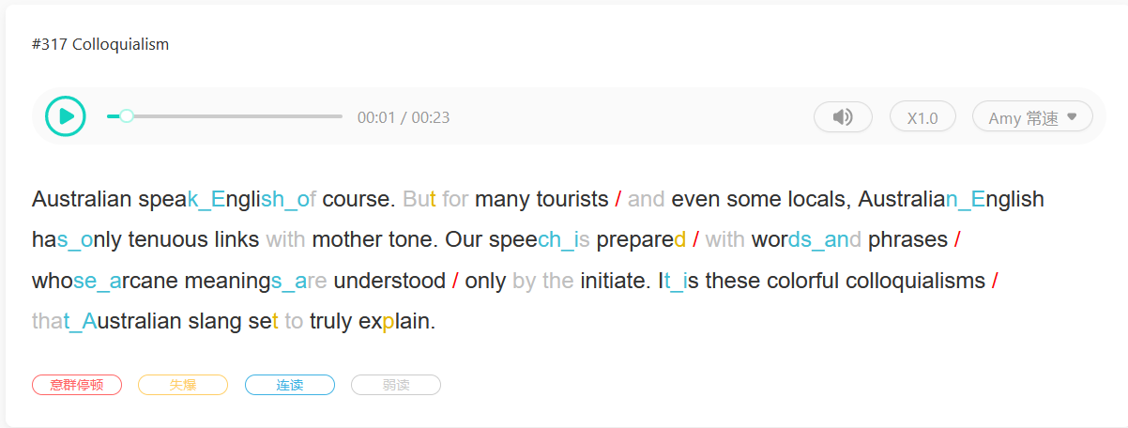

#### #250 https://www.apeuni.com/zh-CN/practice/shadowing/250

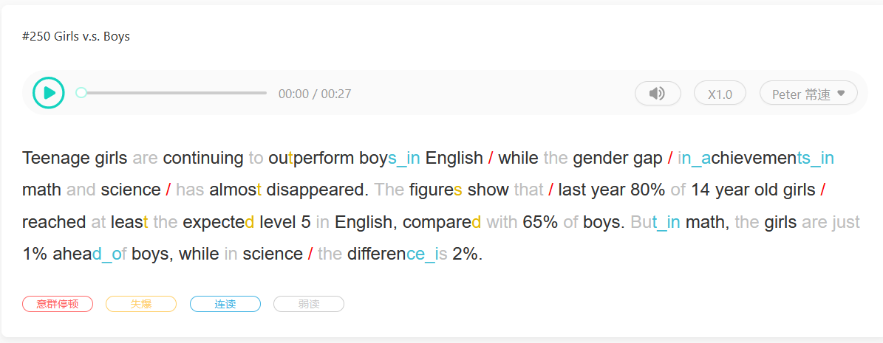

意群划分的停顿到底该多长？另一方面我有拖长音的习惯，在意群结尾尽量短促。

#### #110

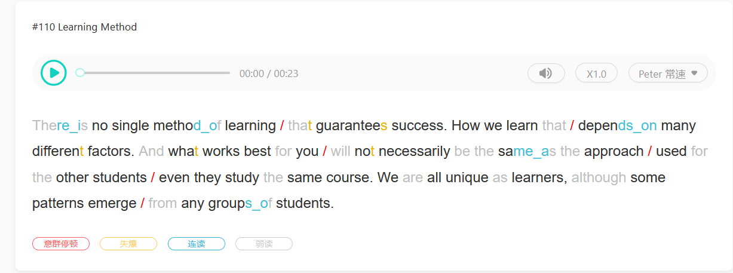

#### # 106

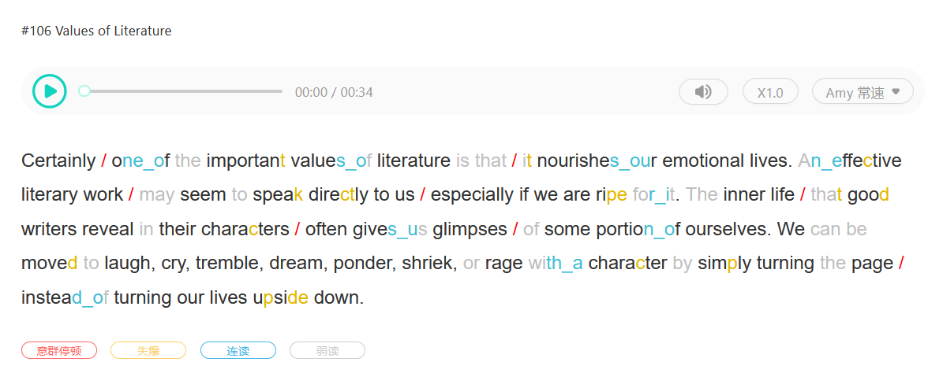

#### #316

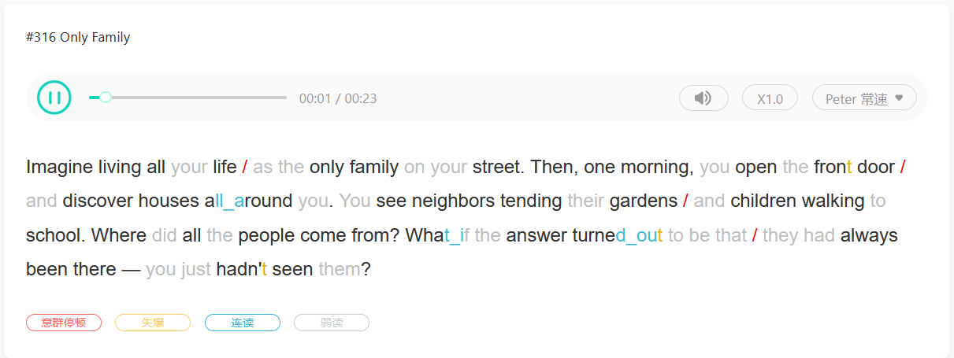

#### #289

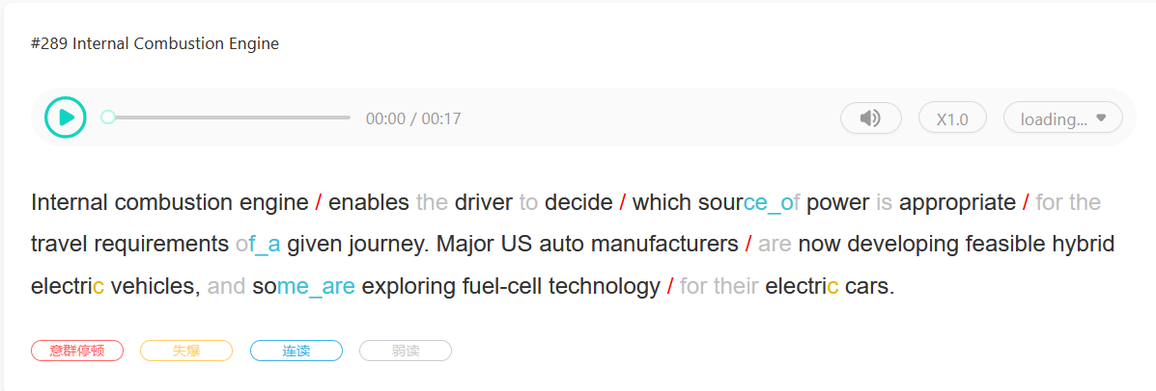

#### # 105

#### # 109

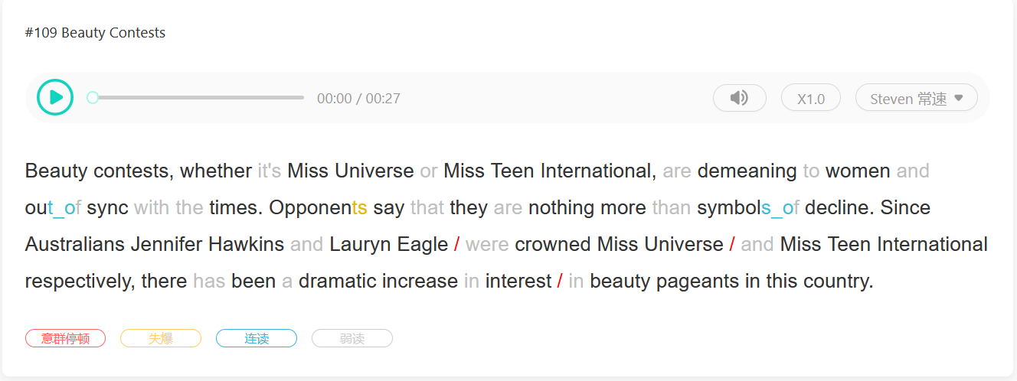

#### #279

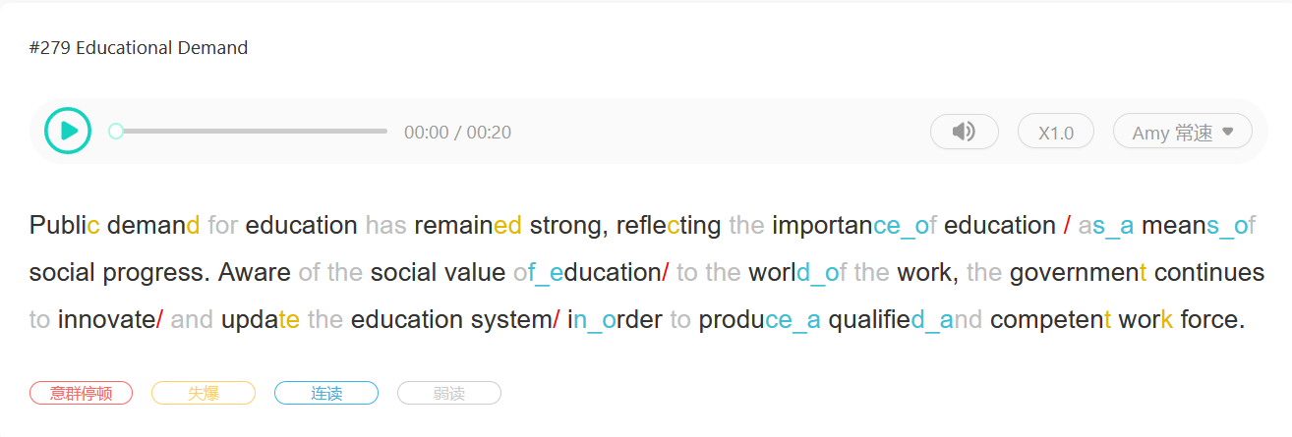

#### #98

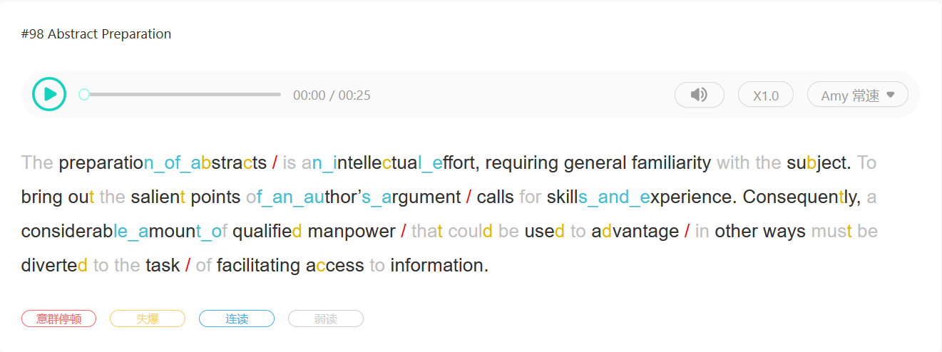

#### #314

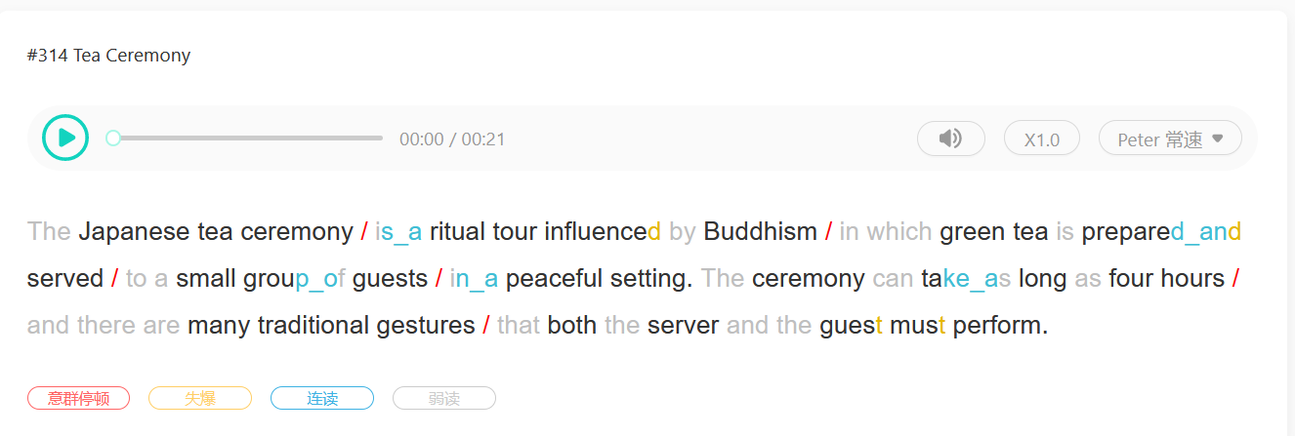

#### #311

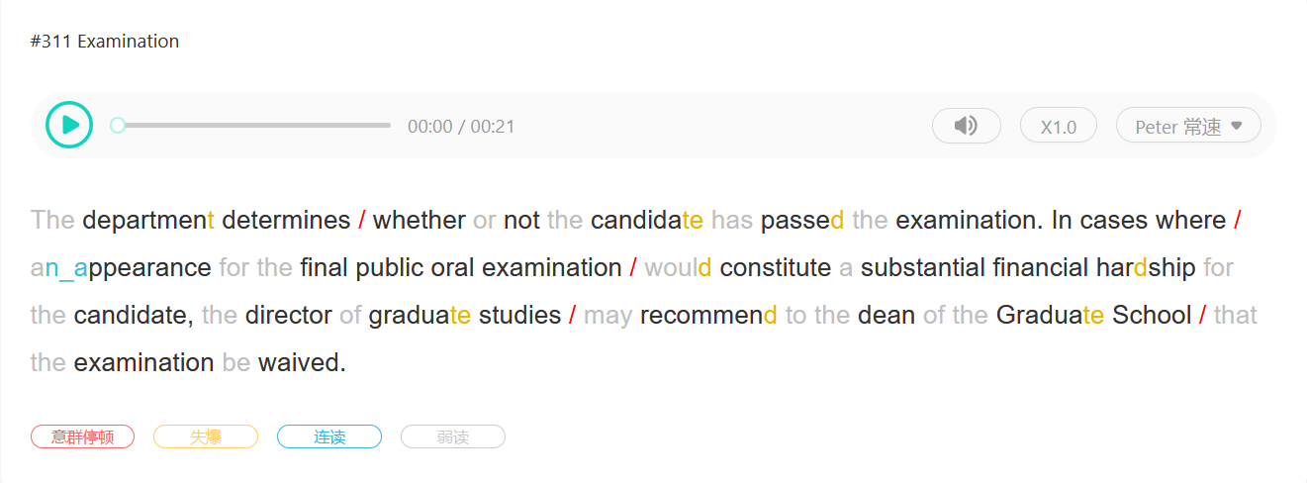

#### #308

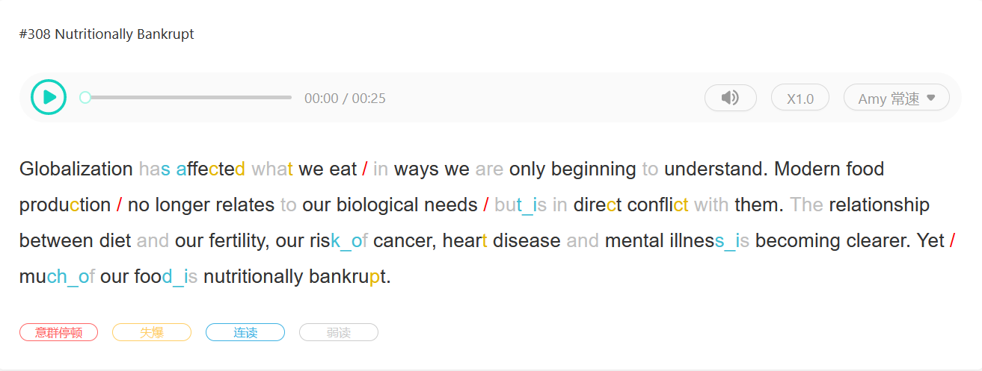

#### #307

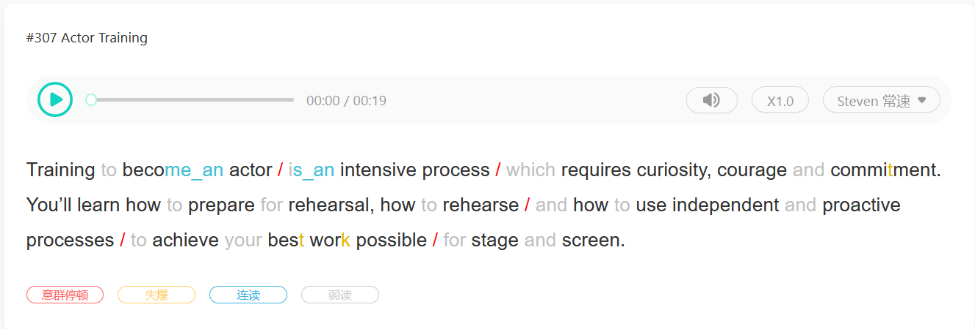

#### #306

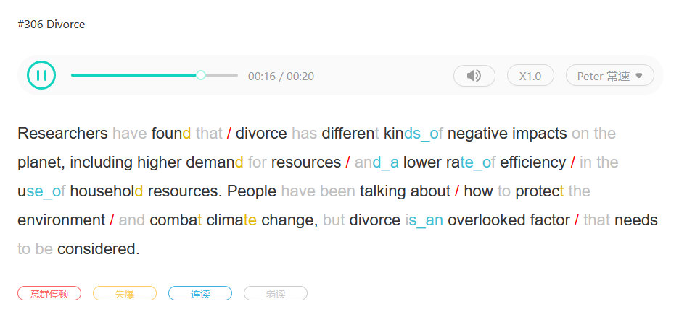

#### #305

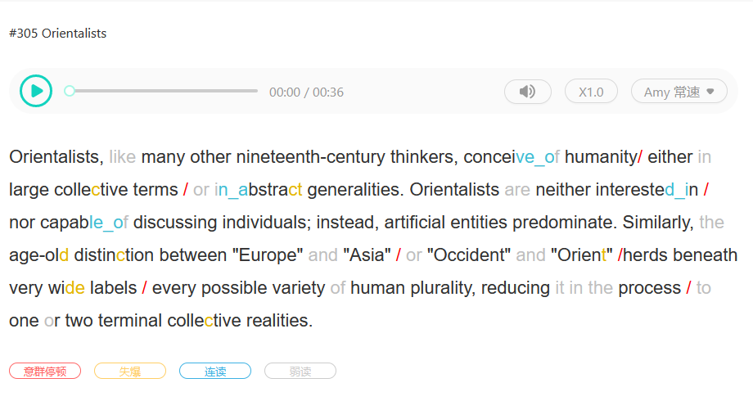

#### #304

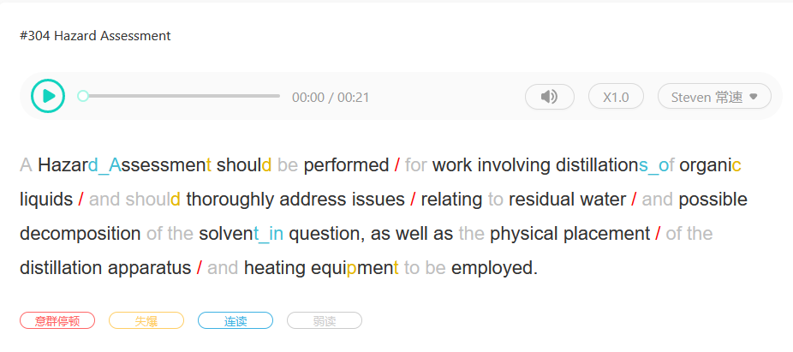

#### #303 (72)

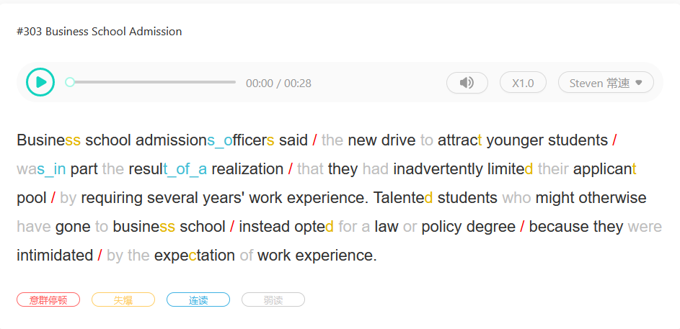

**如果在准备时间发现这段比较拗口，不要刻意加快语速，否则会导致单词含糊不清**

#### #302 （70）

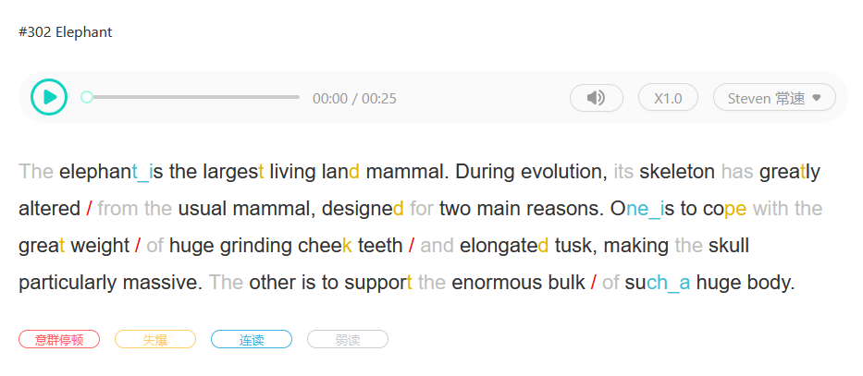

#### #301 （70 -> 76）

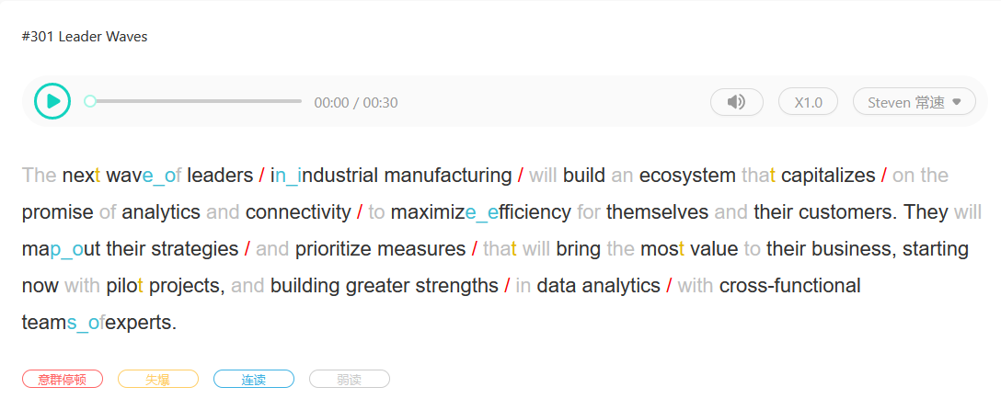

**流利度到底有多大程度上取决于速度呢？这道题忽略意群间隔，只在标点符号出停顿后，反而分高了**

#### #300 （70）

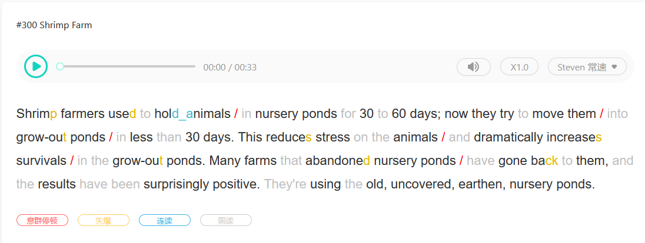

#### #299 (77 )

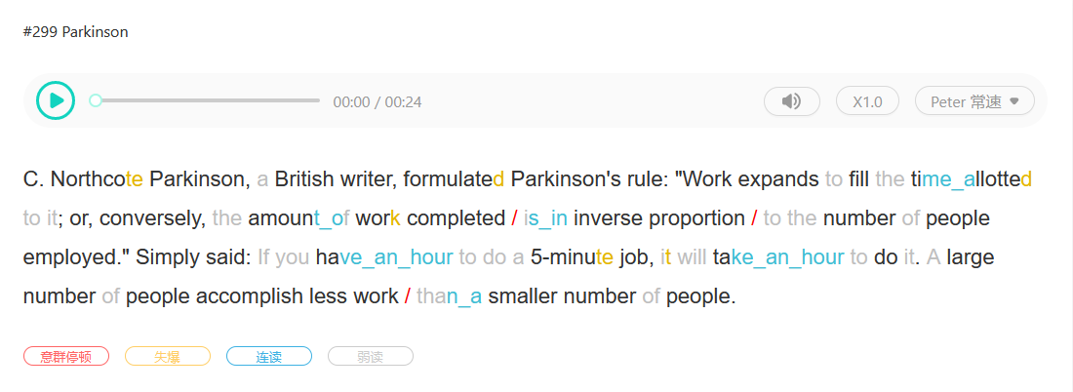

#### #298 （78 -> 81）

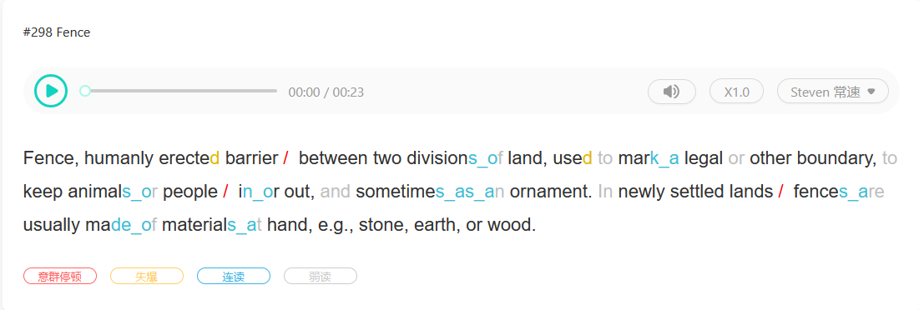

#### #297 (83 -> 85)

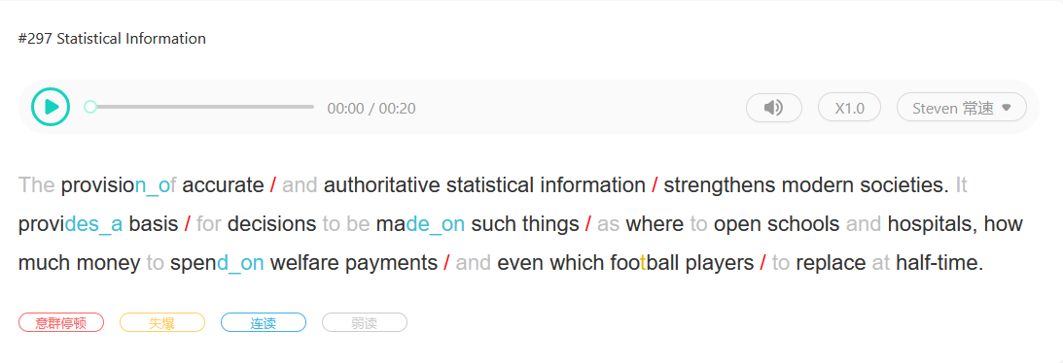

#### #79 (72 -> 86)

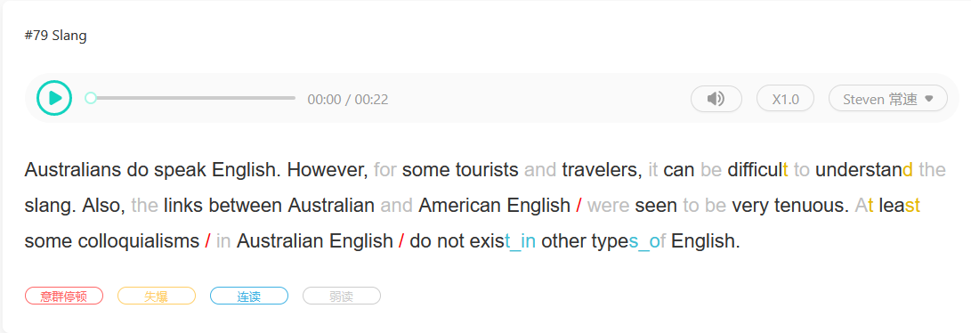

**弱读虚词后分数提升很大**

#### #294 （74 -> 68）

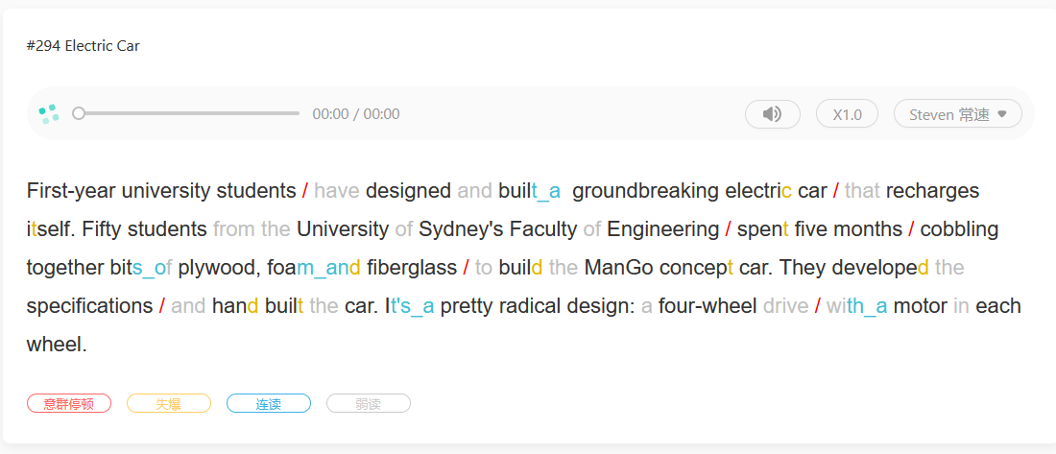

#### #115 (76 -> 78)

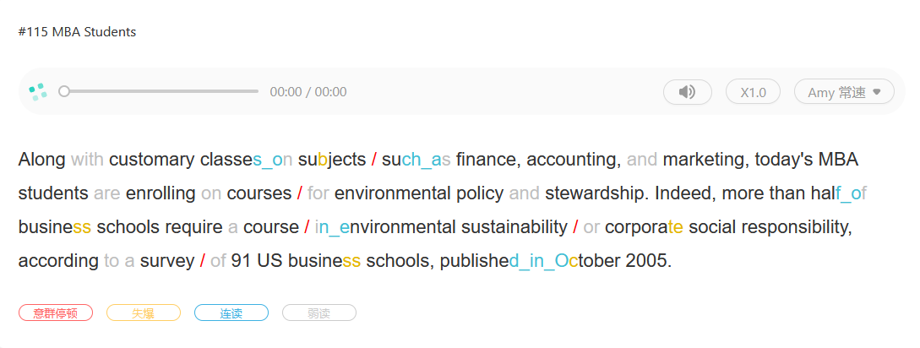

## Repeat Sentence (10-12, Listening & Speaking)

### Requirement

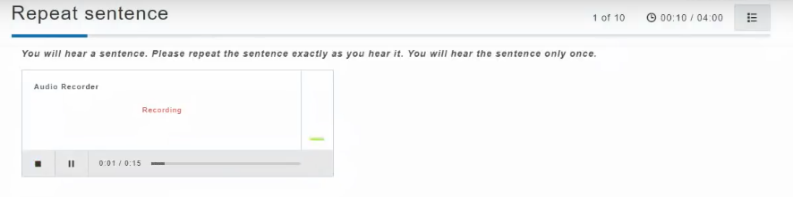

Listen to a sentence about 3-9s and repeat it

**No preparation time, No short tone, Speak right after the recording ends**

Scored on:

* Content: 内容是否一致
* Oral Fluency：是否连贯
* Pronunciation：发音是否标准

### Tips

Copy how the speaker **pause** and **stress words** as in the sample



**There’s not short tone, so speak right after the recording end**

**RS Content只占三分，所有词顺序正确就是满分（就算不是满分，最终也可能是90）**

**所以重点在于Oral Fluency 和 Pronunciation （语法无所谓，单词错了也要自信的说出来）**

**不必要记笔记（可能来不及，也没必要追求内容）**

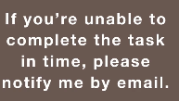 这里就算记不住后半句，说**by email is very good（也就是瞎讲）**也无所谓，关键是Oral Fluency 和 Pronunciation

### 总结

1. **比较难记住长句，流利度和发音相对问题较小（因为句子短？）**
2. **现场瞎编可能卡住，如果没记下来就重读之前的内容**
3. **不要因为想不起来而停顿 （千万不要停，瞎编单词即可）**
4. **不要可以模仿原文语调（可能导致低分），像读RA一样回答即可**

### 进度

#### #1 Next time, we will discuss the influence of the media on public policy

就算我读成了next time, we will discuss the influence of public media on public policy 也有 83

#### #2



#### #3

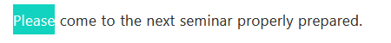

#### #4



#### #5

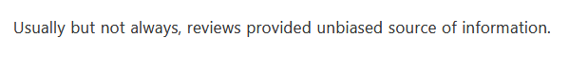

#### #6



#### #7



#### #8



#### #9



#### #10

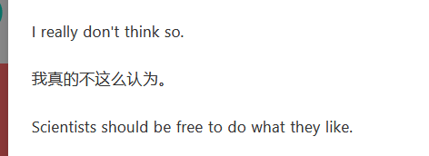

#11

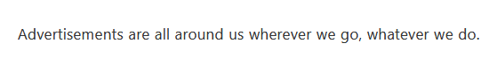

#### #12

#### #13 (84)



#### #14 (79)



#### #15 (81)



#### #16 (80)



#### #17 (83)



## Describe Image (6-7, Speaking)

### Requirement

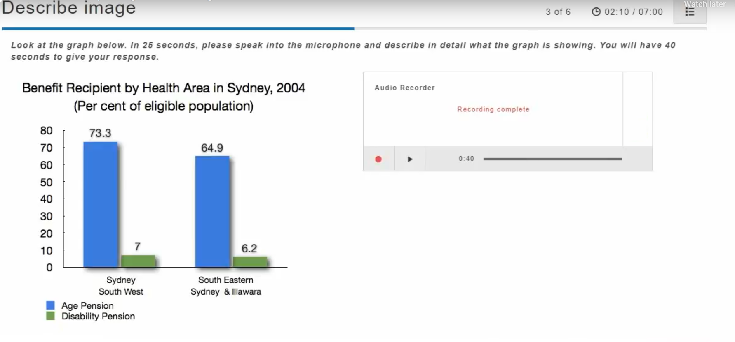

Describe the image on screen

**25s to prepare, 40s to answer**

Scored on:

* Content: 内容是否一致
* Oral Fluency：是否连贯
* Pronunciation：发音是否标准

### Tips

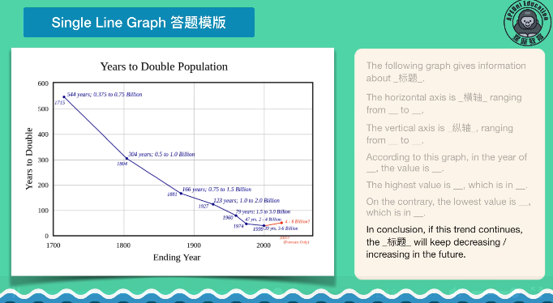

Focus on the **main information** in the image: Use noteboard to note down **key ideas** and **phrases**

**Organize** the description of images

DI占分比重高

**无脑套模板，语法无所谓（PTE的听力都是一样）**

**以下图为例，就算2000年说成200年，或者数据看错也无所谓**

**另外最后一段，上升，下降随便说。【内容无所谓！！！】**

**将错就错，挑顺口的读，务必不要重复**

7种DI题型：

* Single Linear
* Multi Linear
* Bar & Pie
* Table & Flow
* Map
* Image
* Combo

### 模板整理

#### Single Line



#### Multi Line

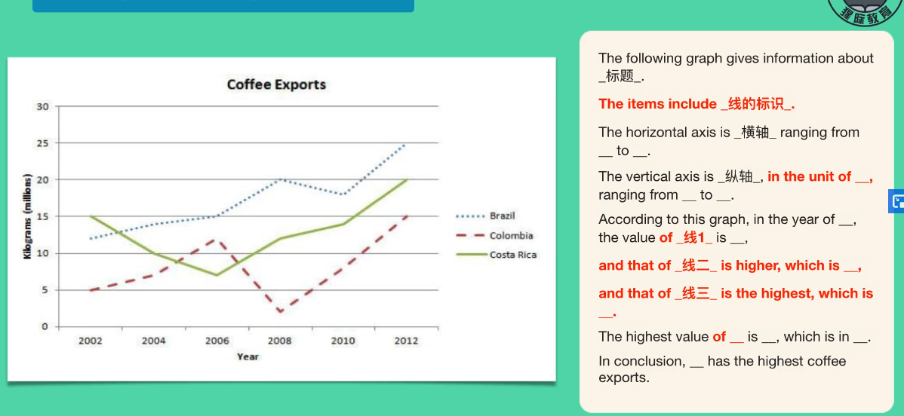

#### Bar Chart

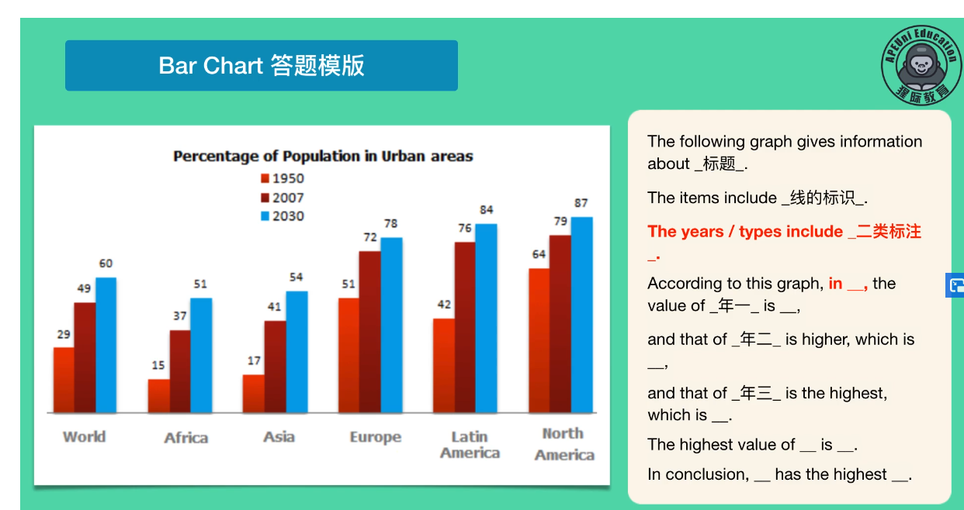

#### Pie Chart

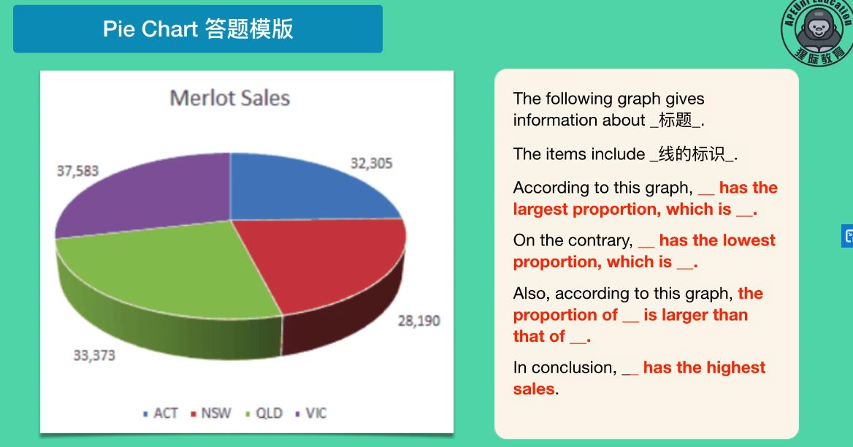

#### Table

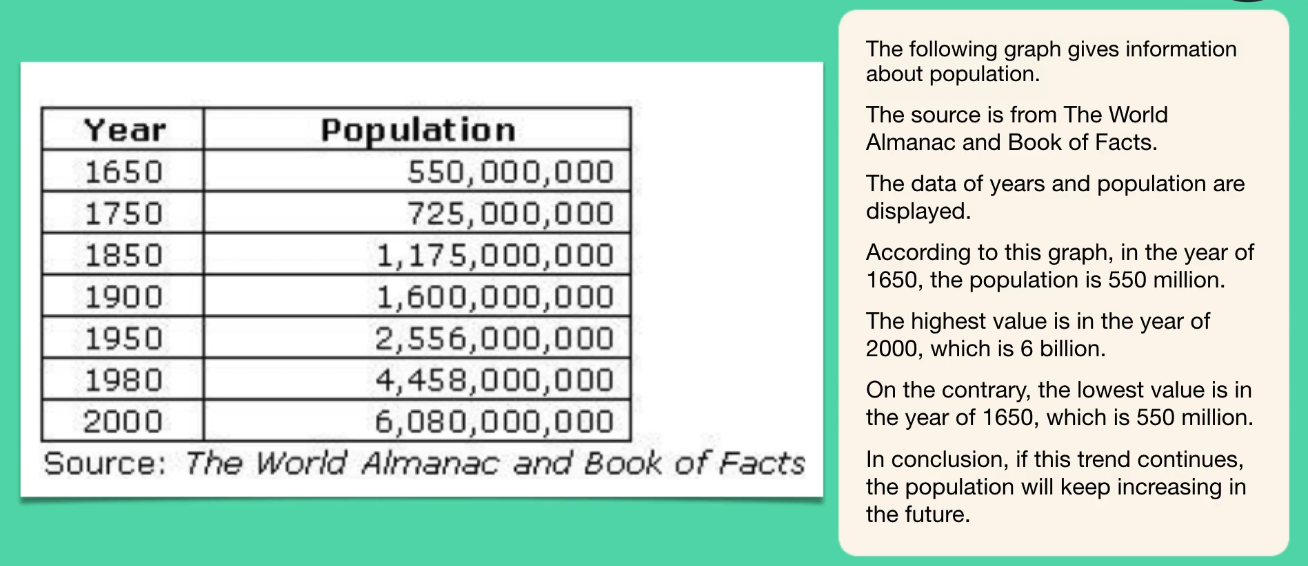

#### Flow diagram

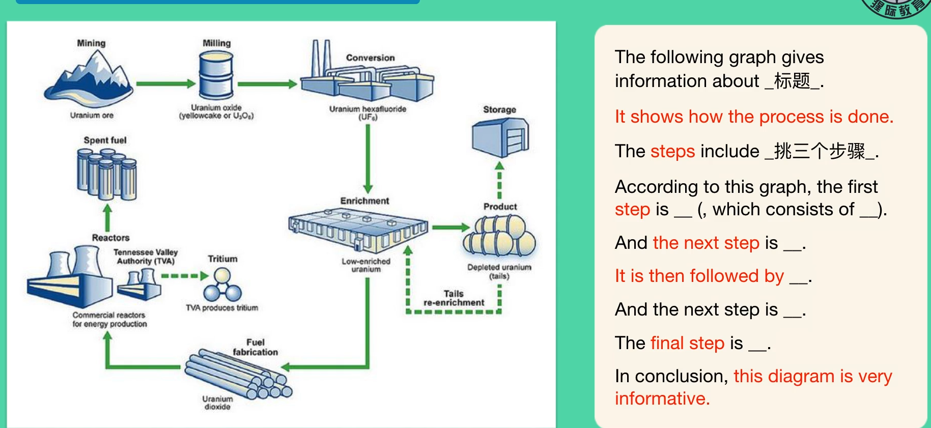

#### Picture

相对最多变，但出现频率不高

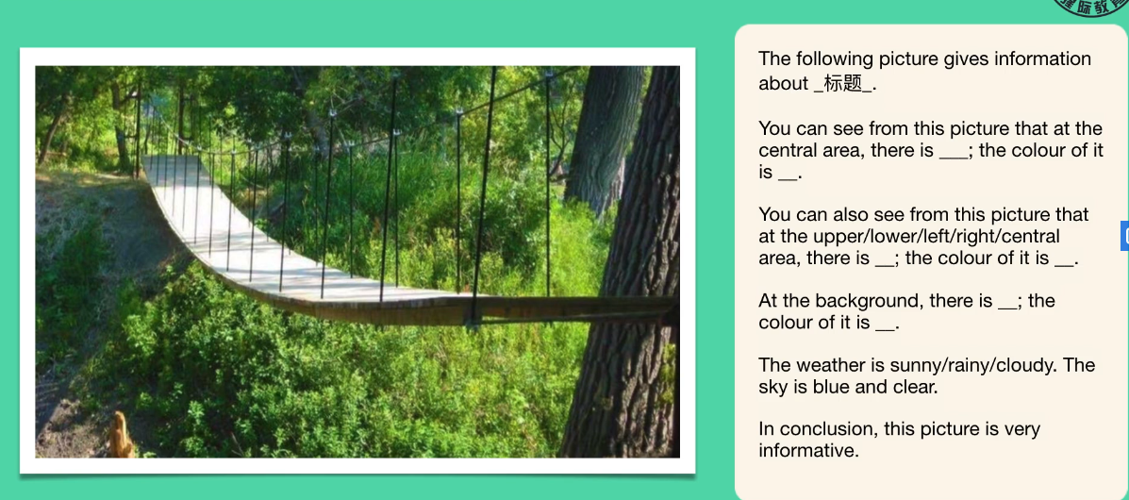

### 总结

### 进度

## Re-tell Lecture (3-4, Listening and Speaking)

### Requirement

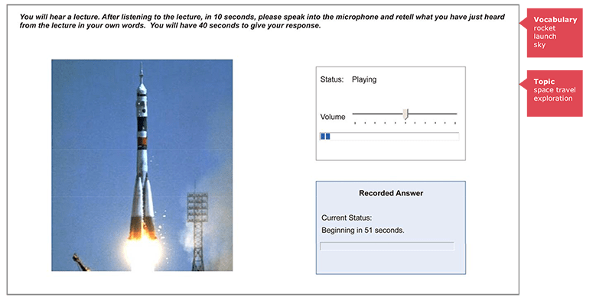

Re-tell a lecture up to 90s (might also be image)

**10s to prepare, 40s to answer**

Scored on:

* Content: 内容是否一致
* Oral Fluency：是否连贯
* Pronunciation：发音是否标准

### Sample

### Tips

You have **3 seconds** before the recording starts to play, use that 3 seconds to think about the image and **related vocabulary and topic**, just like the sample above:

Rocket, Launch, Sky, Space…

In the 40s answer, try to include all main points of the main points, **DON’T HESITATE, KEEP TALKING AND IGNORE MISTAKES YOU MADE**

开始时：注意主题

记笔记时：省略不重要的内容，记下反复强调/重音的内容

记短语/短句， 为流利作答做准备

只要主题对，错过1，2个点问题不大

以模板为基准记笔记：

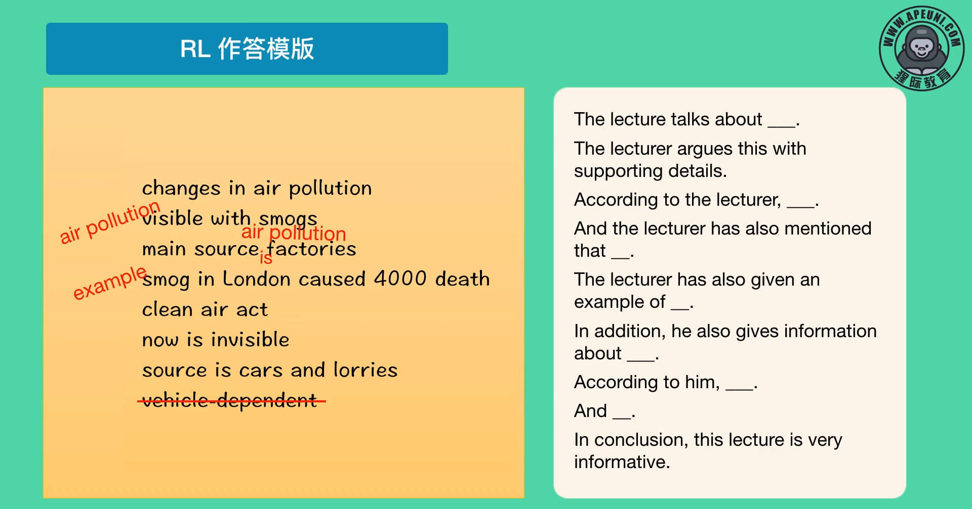

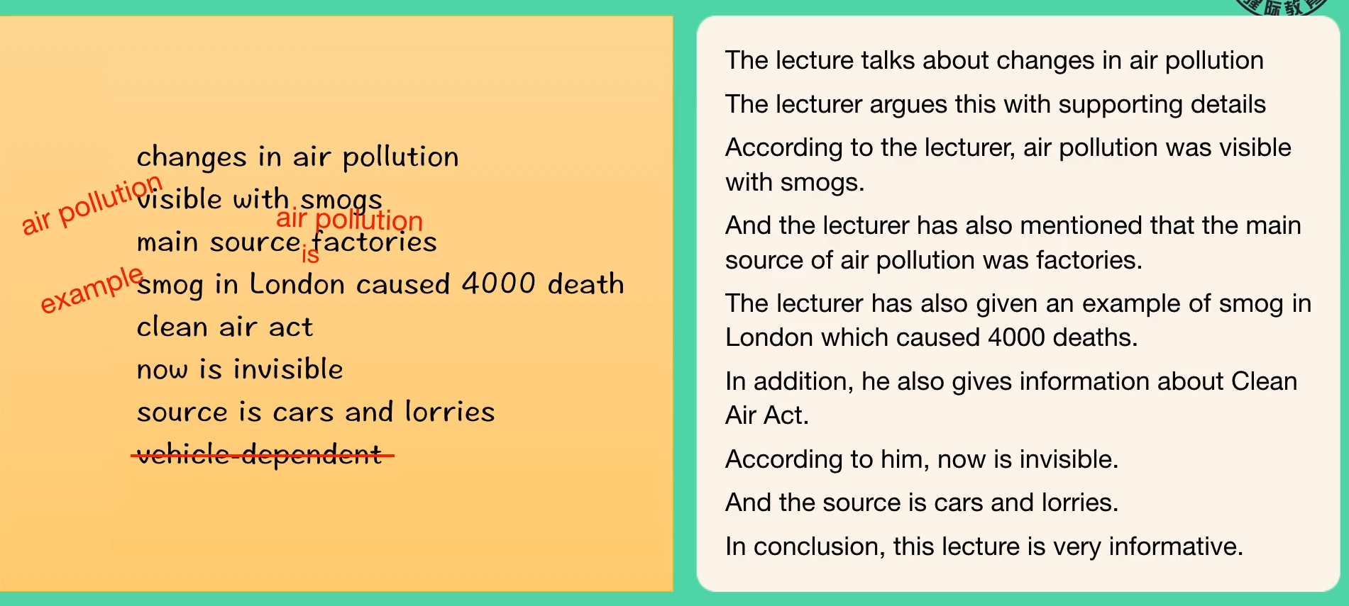

## Answer Short Question (10-12, Listening and Speaking)

### Requirement

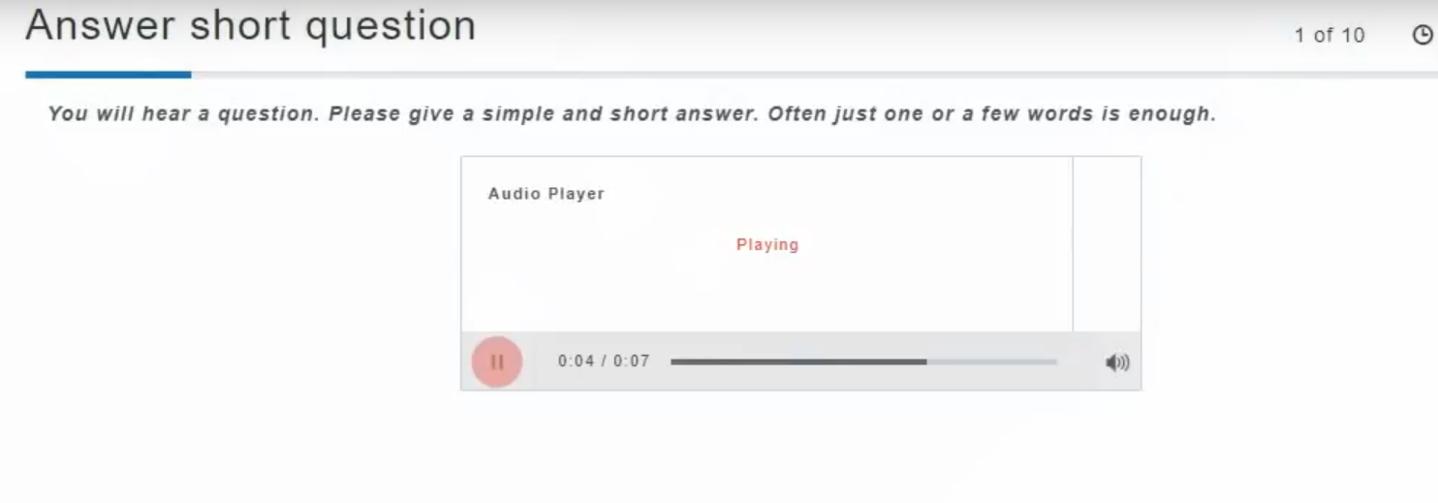

Answer short question with a single (or a few) words (might also be image)

**No preparation time, 10s to answer**

Scored on:

If the answer is correct (its either correct or incorrect)

### Tips

**Don’t wait for more than 3 seconds**

Make your answer **short** and **accurate** (NO EXTRA MARKS for additional words)

For example, what type of periodical is published on a daily basis?

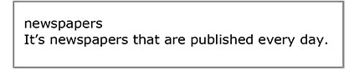

**这两种答案同样得分**

### 总结

1. 答案基本都是一个单词或词组
2. 答案可以重复多次：Book, Book, Book
3. 单词发音切记简短有力，不要拖长音

<https://www.apeuni.com/zh-CN/practice/answer_questions/13>

以此题为例，newscaster拖长音念就无法识别

# Writing

题型：

1.7 Summarize Written Text

1.8 Essay

## Summarize written text (2-3, Reading and Writing)

### Requirement

After reading a text, write a one-sentence summary of the passage.

10 minutes to write, no more than 75 words

Scored on:

Content 概括是否准确

Form: 是否符合字数要求

Grammar：语法是否正确

Vocabulary: 用词是否准确

**Its either correct or incorrect?**

### Sample

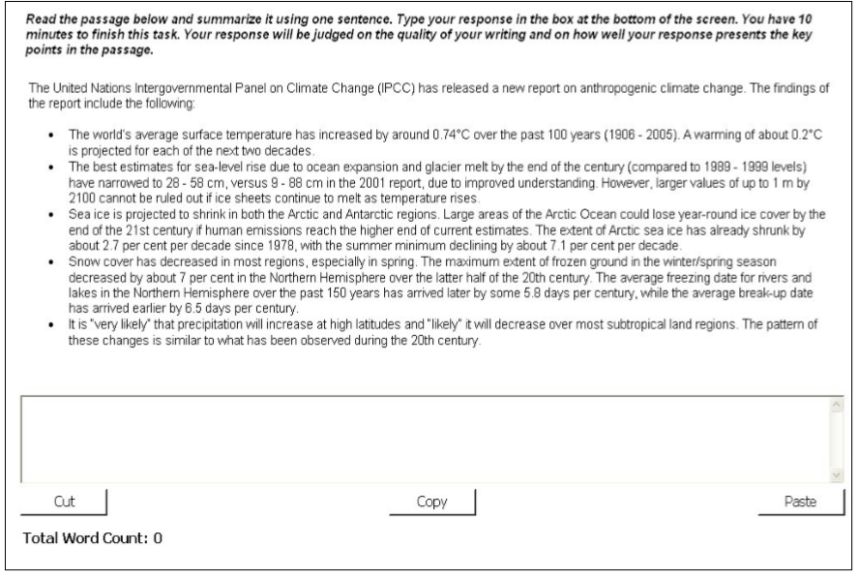

### Tips

**WRITE IN ONE SENTENCE**

Since its only one sentence, you should use a **complex** or **compound** sentence to summarize the main point, but also briefly mention the supporting detail

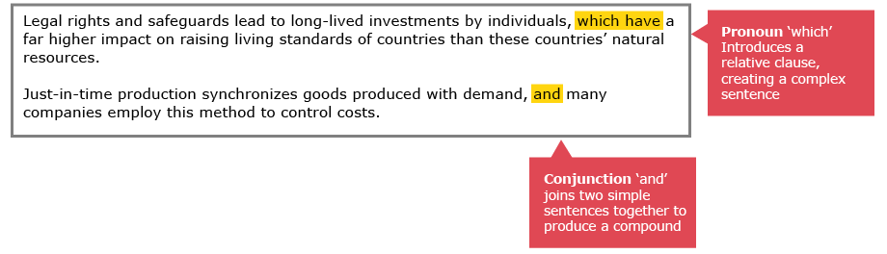

## Essay (1-2, Writing)

### Requirement

Write a 200-300 words essay on given topic in 20 mins

Scored on:

* Content
* Development, structure and coherence
* Form
* General linguistic range
* Grammar usage and mechanics
* Vocabulary range
* Spelling
* Note

### Sample & Tips

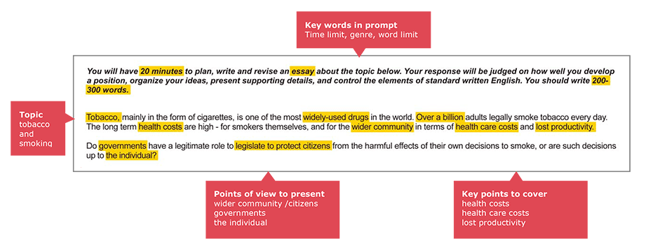

**提炼重点**

# Reading

## 题型

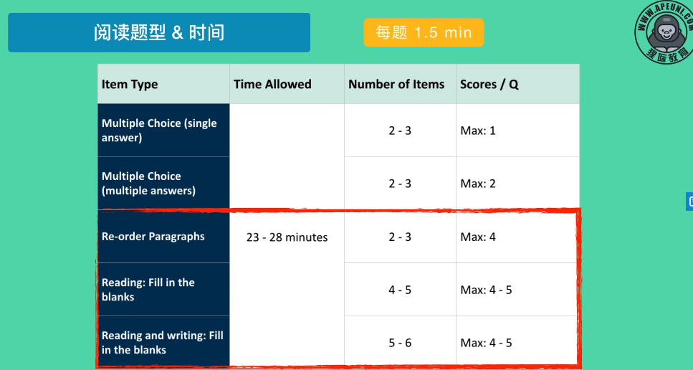

### Reorder Paragraphs

It’s pretty easy honestly

## 2.1 Fill in the blanks (5-6, Reading and Writing)

### Requirement

Select correct word in gaps between a passage

Scored on:  
Corrected or not

### Sample

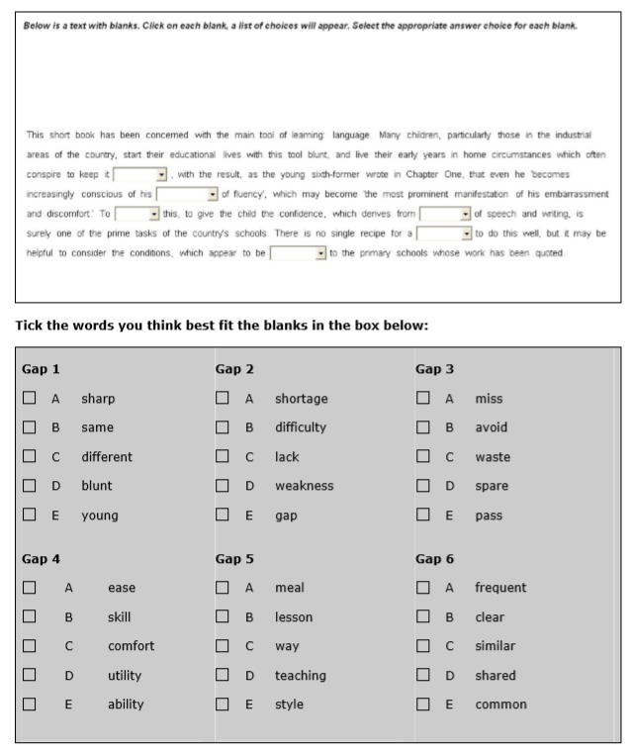

### Tips

**Skim for overall meaning**

## 2.2 Multiple choice, Multiple Answers (2-3, Reading)

### Requirement

After reading a text, answer a multiple choice question on the content or tone of the text by **selecting more than one response**

Scored on:

**选错倒扣分**

### Sample

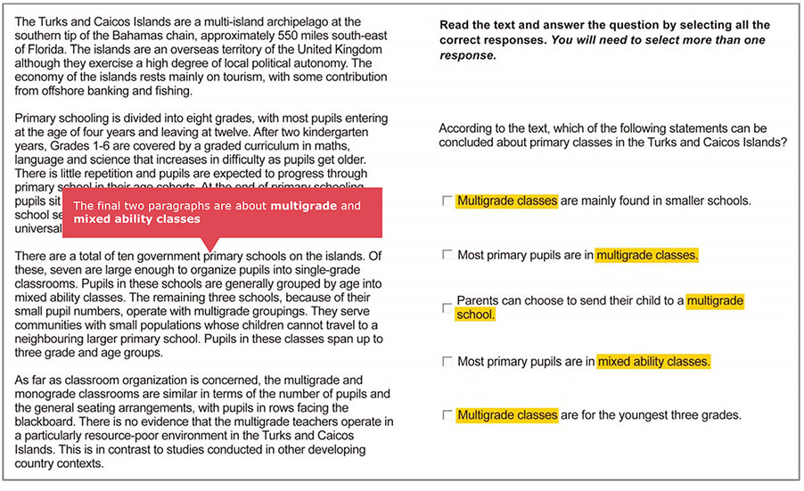

### Tips

Skim through all options, if some words are repeated, it’s probably related to the topic

### 总结

* **单选和多选题 分值较小，不要浪费太多时间(超过两分钟)**
* **多选题有多个答案， 答错扣分，不确定的情况下不要乱选！**

## 2.3 Reorder paragraphs (2-3, Reading)

### Requirement

Put several text boxes in correct order, at most 150 words

Scored on:

If the order is correct

### Sample and Tips

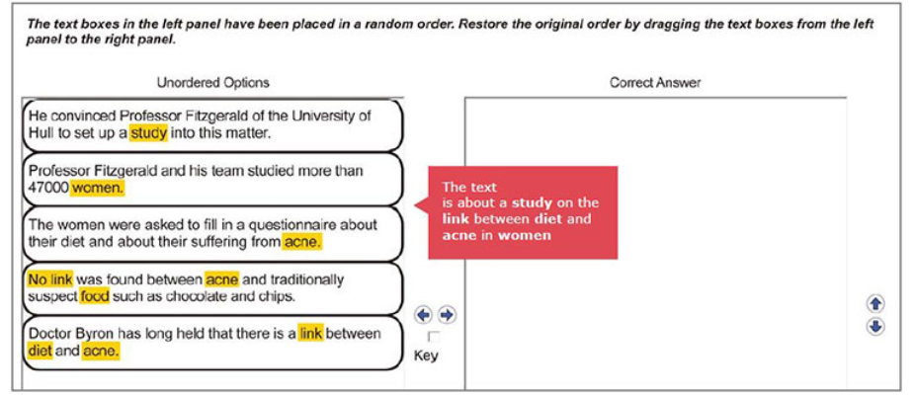

Read all text boxes before re-ordering while noting the key words

### 总结

It’s pretty easy tbh

## 2.4 Fill in the Blanks (4-5, Reading)

### Requirement

Drag words from the box below to fill the gaps (Difference to 2.1: Some words may not be used)

Text up to 80 words

### Sample

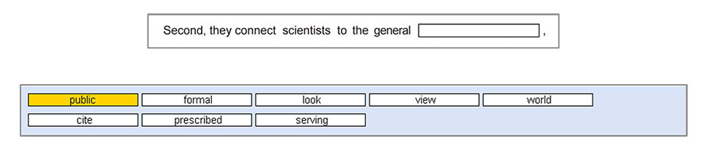

### Tips

联系常见词组

根据语法判断

## 2.5 Multiple choice, Single Answer (2-3, Reading)

### Requirement

Same as 2.2, but only one correct answer

### Sample

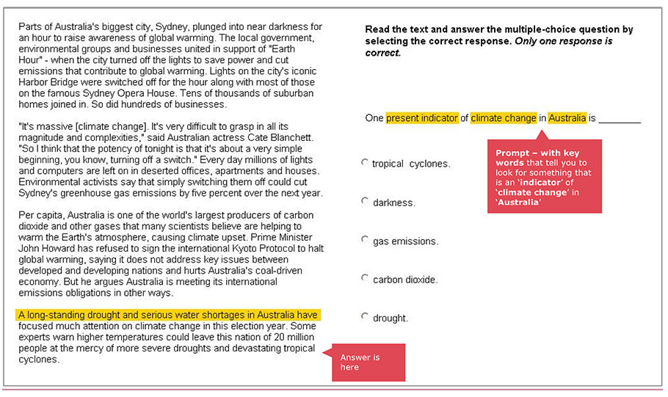

### Tips

Note the key words, as the sample do

Identify incorrect answer using general knowledge

### 总结

* **单选和多选题 分值较小，不要浪费太多时间(超过两分钟)**

# Listening

## 题型

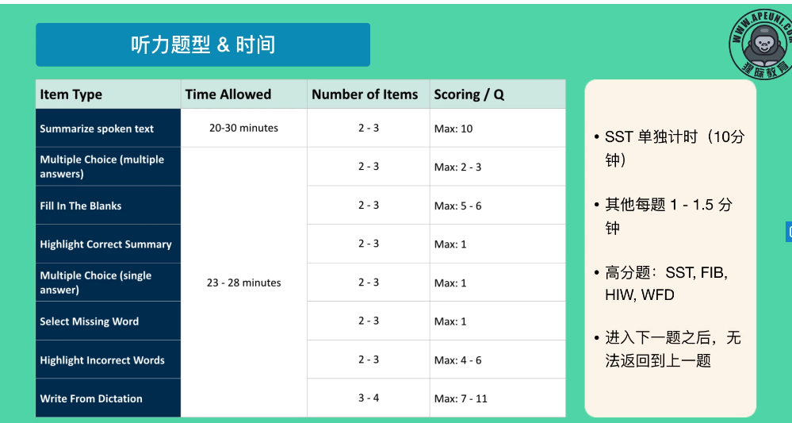

**拎清重点，HCS，SMW分数都非常低，不要再这类题型上浪费时间**

## 3.1 Summarize Spoken Text (2-3, Listening and Writing)

After listening to a recording, write a 50-70 words summary **in 10 minutes**

### Tips

Summarize the main point and refer briefly to the essential supporting points

Remember to check grammar, spelling and punctuation

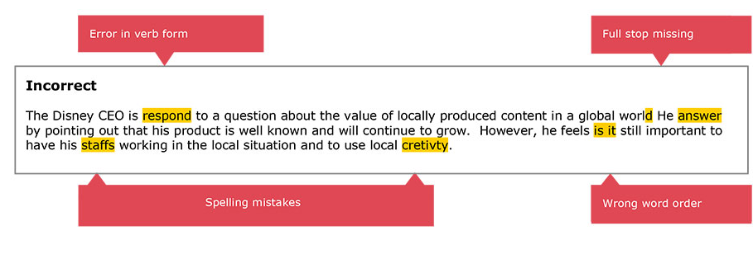

### 总结

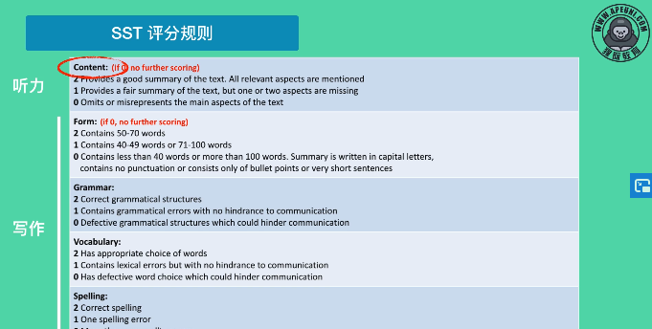

* **只有content的两份算听力，其他80%都算writing：类似RS强调流利度和发音，而非内容**
* **Form：只要写满50-70字，就是满分**
* **Grammar：错一个就只有一分**
* **Vocabulary: 尽量写原文词汇，不需要用复杂词**
* **Spelling：错一个1分，错两个0分 （所以检查语法/拼写非常重要）**

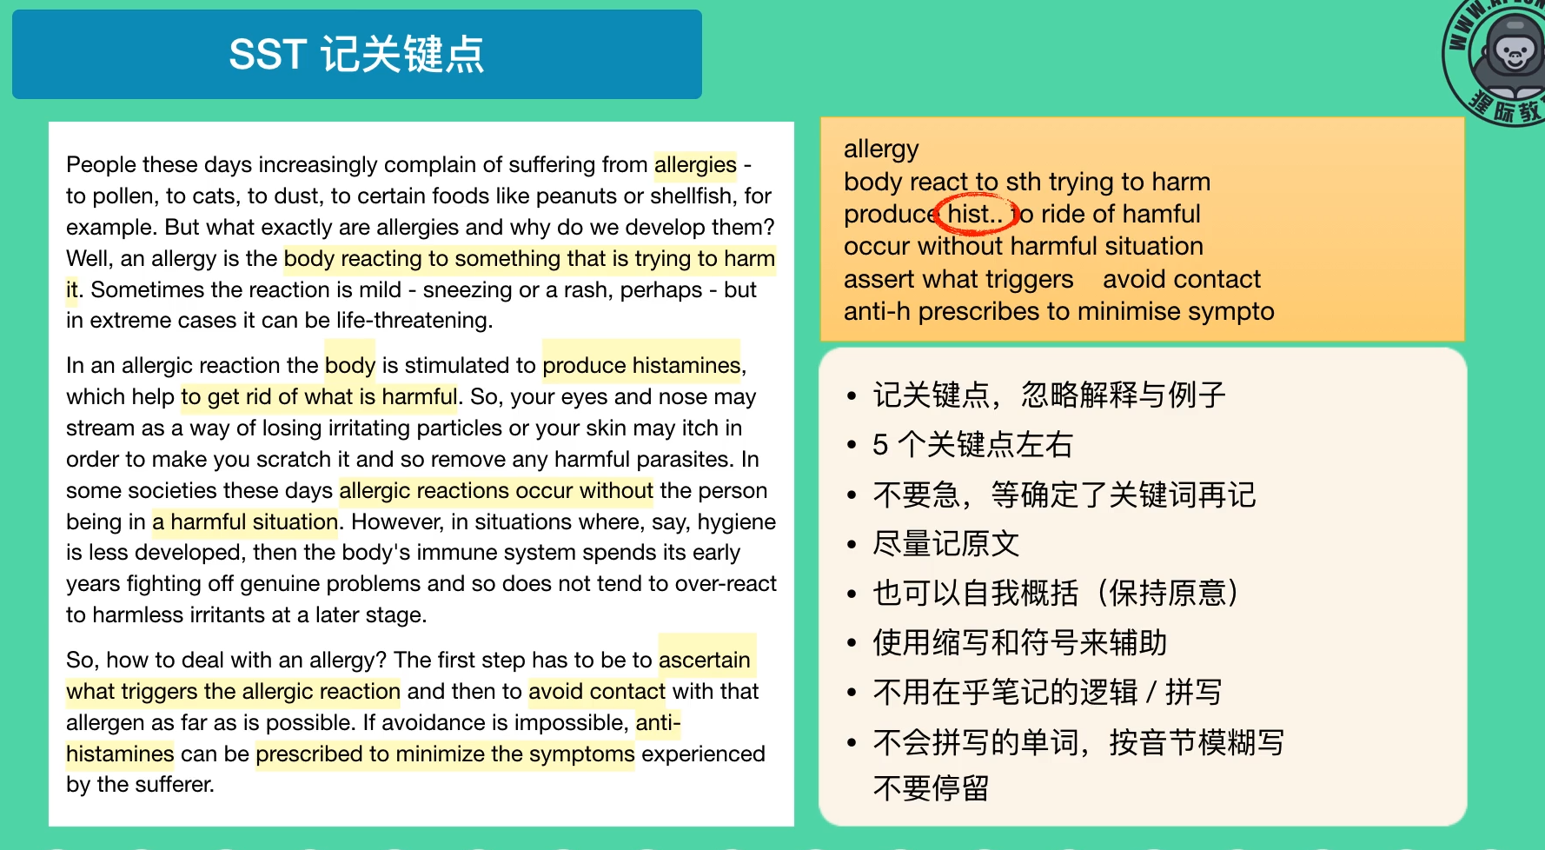

* **不会拼的词不要硬拼，用其他词替换**
* **只记录关键点（5个左右），无视例子**
* **最后（通过模板）讲关键点笔记组合成段落即可**

## 3.2 Multiple choice, multiple answers (2-3, Listening)

Listening to a recording, answer a multiple-choice question

### Sample

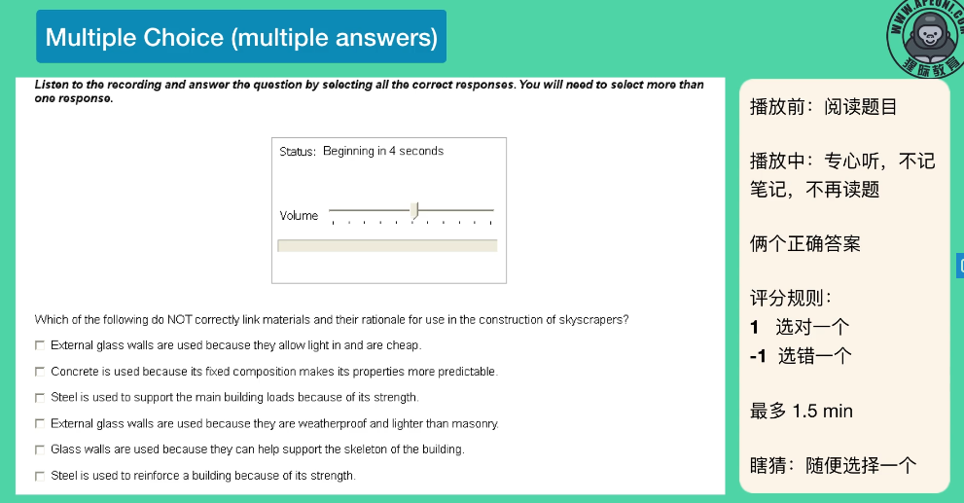

### Tips

Use 7s before the recording start to **read the question** and **get ready to TAKE NOTE**

Select the options that best **match the meaning**, **not words**

### 总结

* **和Reading中多选题一样，选错倒扣分**

## 3.3 Fill in the blanks (2-3 Listening and Writing)

### Requirement

Listen to transcript and fill in the gaps

Only scored on content: If the word is correct

### Sample

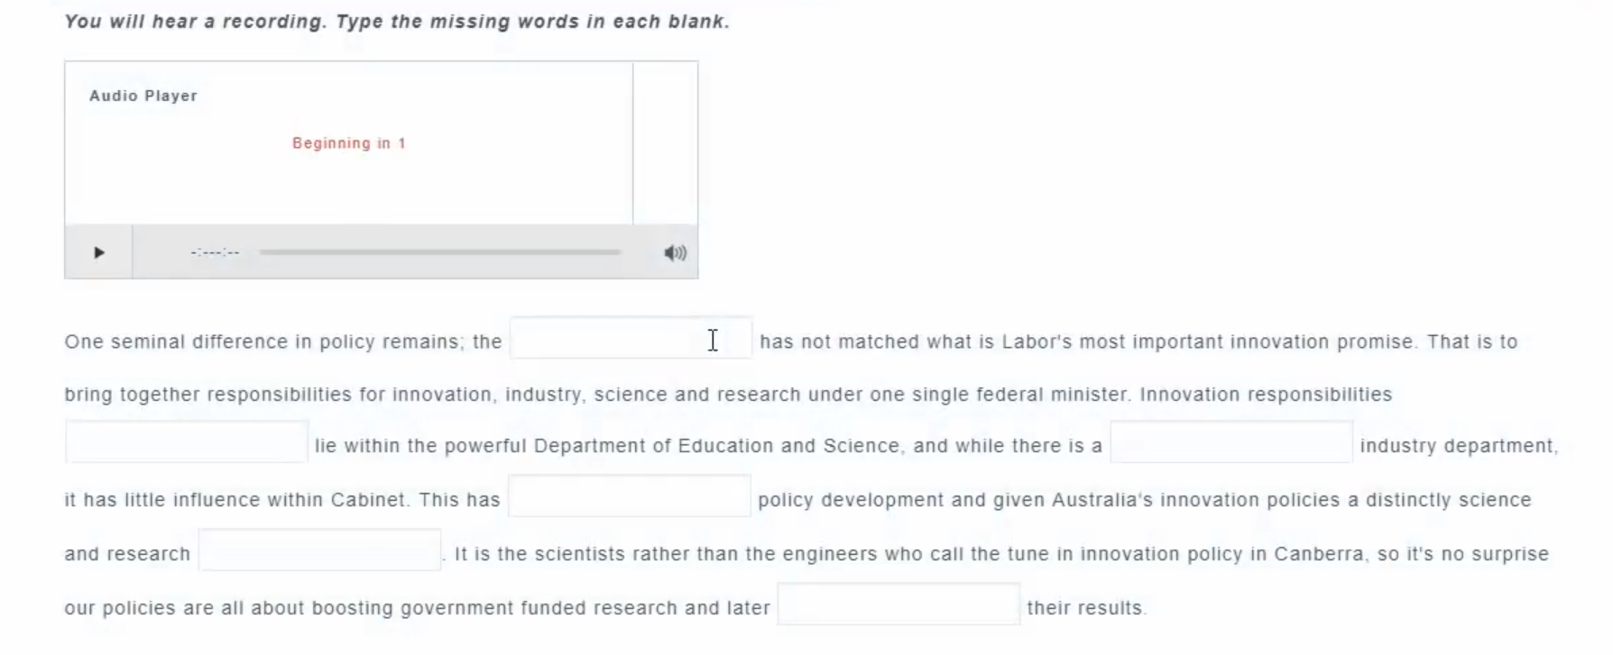

### Tips

Skim the text before recording begins

Write down **WHAT YOU THINK YOU HEAR**, because there is **NO TIME** to think about the spelling

## 3.4 Highlight correct summary (2-3 Listening and)

### Requirement

After listening to a recording, select the paragraph the best summarizes the recording

### Sample

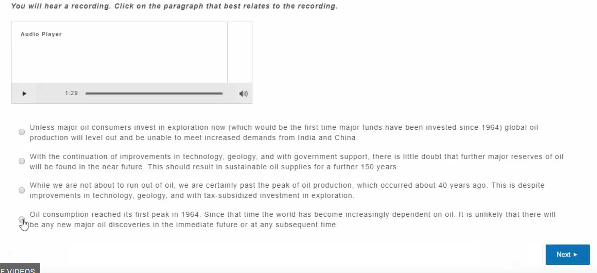

### Tips

Take notes

**But don’t read these options before the recording starts as they are too much**

**总共就一分，不要浪费时间**

## 3.5 Multiple choice, Single answer (2-3, Listening)

### Requirement

Same as 3.2 but only one answer

## 3.6 Select Missing word (2-3, Listening)

### Requirement

Listening to a recording, select the missing word (*Beep*) that completes the recording from a list

### Sample

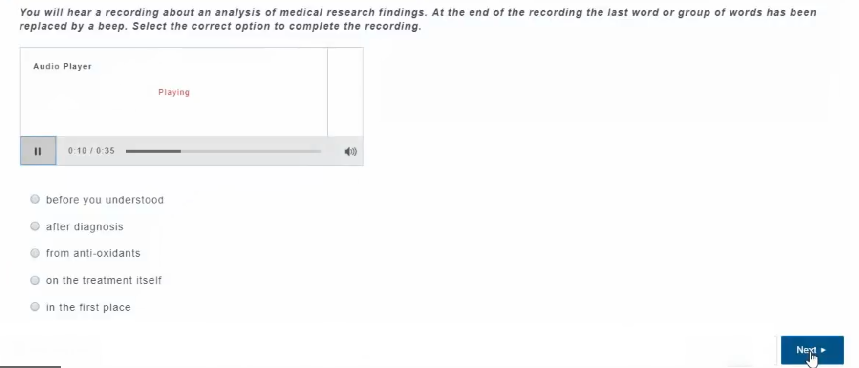

总结

**没什么难度，分值低不要浪费时间**

## 3.7 Highlight Incorrect Words (2-3, Listening and Reading)

### Requirement

Listening to recording and identify words are different from what the speaker said

### Sample

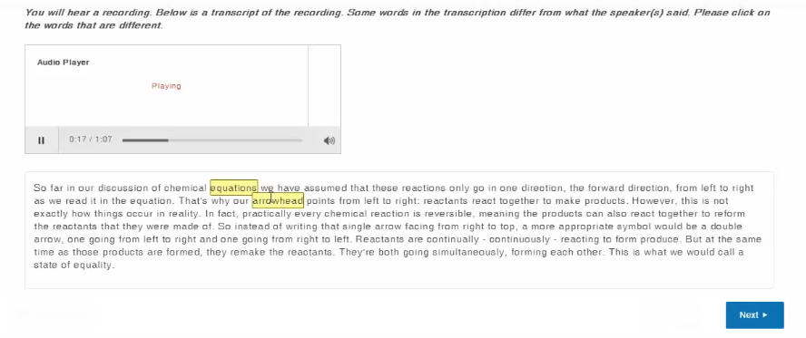

### Tips

**Keep Your Cursor with the Recording**

**Skim the transcript first**

## 3.8 Write from Dictation (3-4, Listening and Writing)

### Requirement

Listening to a 3-5s recording, and type the sentence (听写)

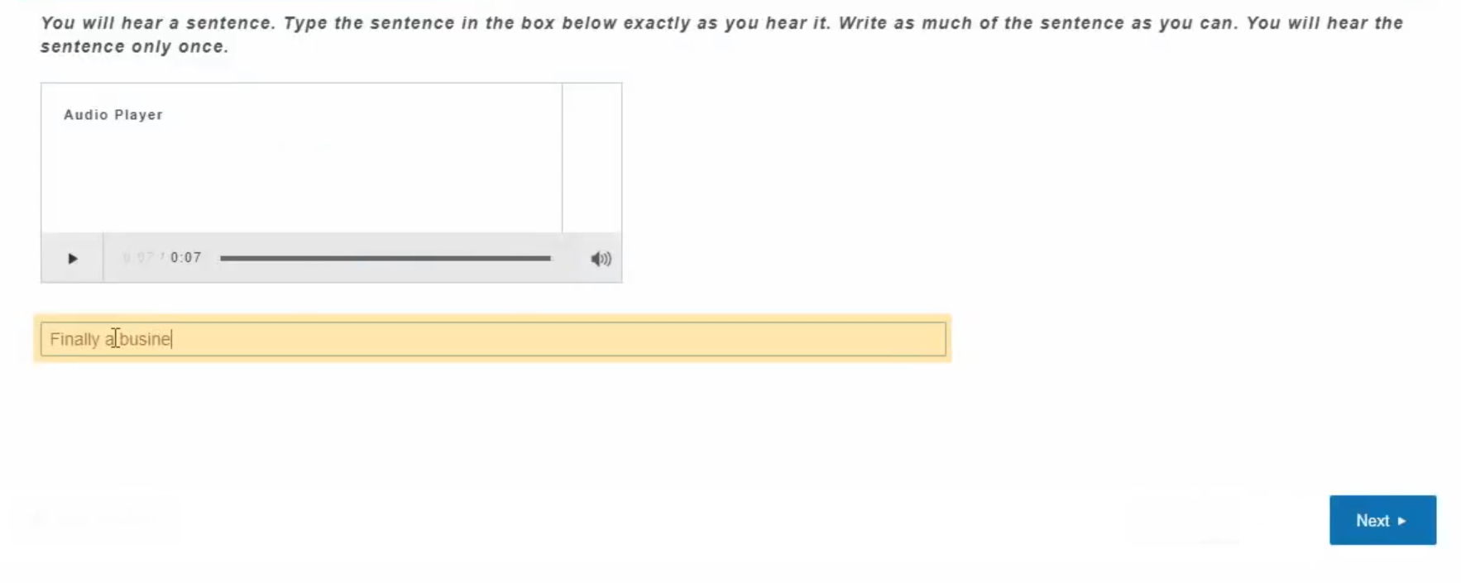

### Tips

More correct words, more points: Write down every correct word you heard and fit it in even you don’t know where

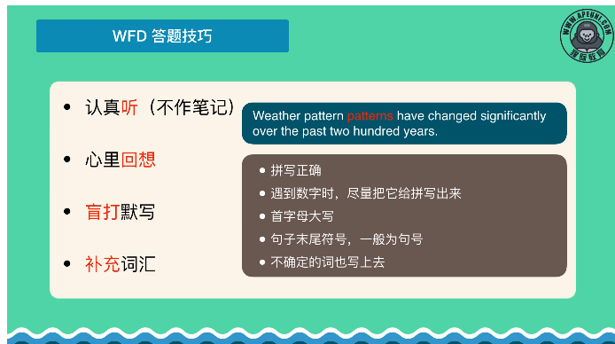

### 总结

* **WFD类似RS，但是RS不强调内容，而WFD则相反**
* **WFD分值极高，且影响Listening & Writing**
* **写对一个单词给一分，写错不扣分 （如果不确定单词拼写等，就都写上去）**

**With pack changing significantly for the past 300 years**